**Project Second Increment Report**

**Features developed for Increment2:**

1. Displaying places of a city, given destination from the user
2. Displaying places of Interest, given destination and Interest from the user
3. Displaying User reviews of a given place
4. Migrating from Local Storage to Mango DB

**Existing Services/REST API:**

<https://console.developers.google.com/google/maps-apis/>

**Detail Design of Features:**

**1. Wireframes& mockup:**

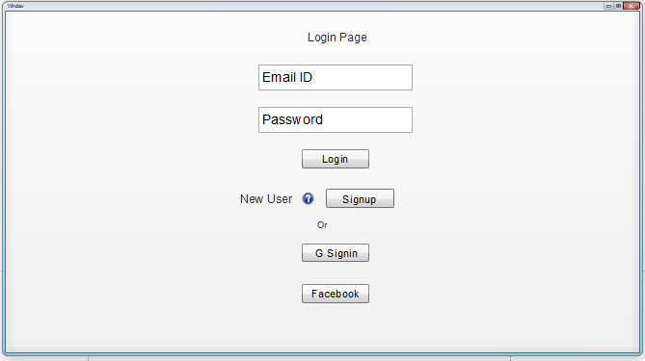

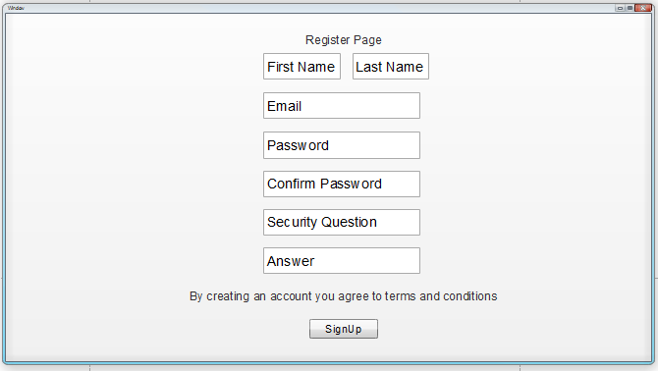

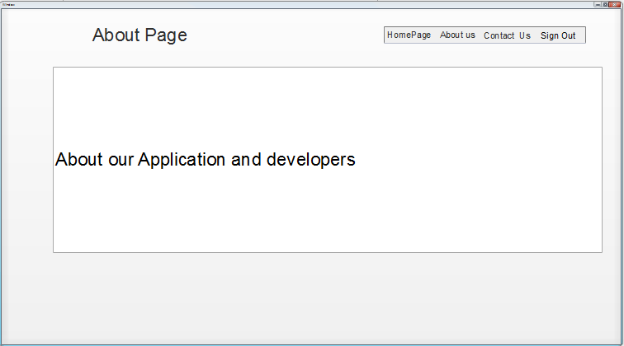

**Basic Functionality:**

First thing that a user should be seeing is a Login page, which has a username and password fields. Once the user provides his/her username and password he/she will be prompted to home page. Login can also be done using Google and Facebook.

User registration is required before logging into the application, on clicking Sign up here link in the login page, user will be prompted to Registration page, where user has to enter details like First name, Last name, Email id, Password, Conform Password, Security question and its Answer, a link to comply with Terms and conditions and then press Signup button.

After successful registration user will be asked to login to the application, after logging in user will be prompted to Home page. Home page consists of tabs to Contact Us, About Us pages where user can see the details of Admin and about the application details.

Any point of time user can logout from the system upon pressing Logout button.

**2. 1 Architecture diagram:**

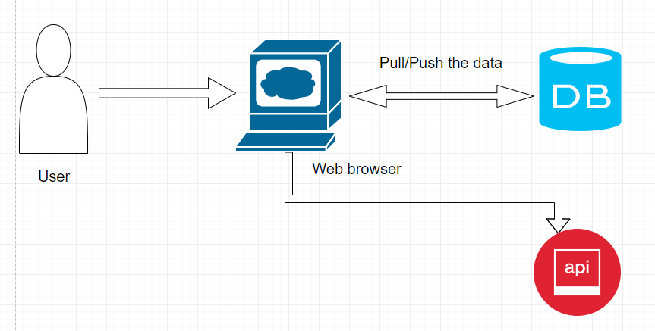

**2.2 Sequence Diagram:**

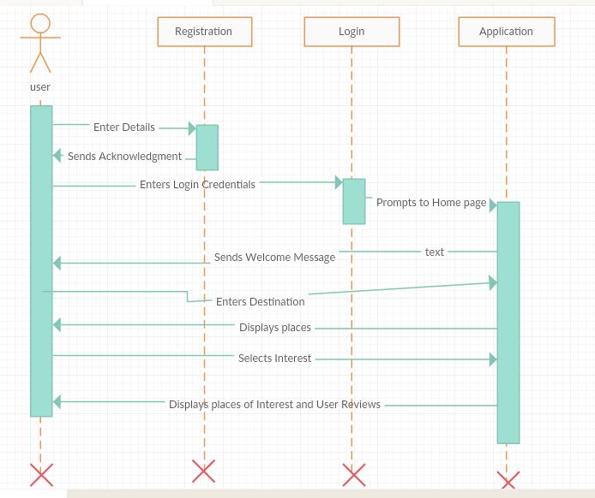

**2.3 Class Diagram:**

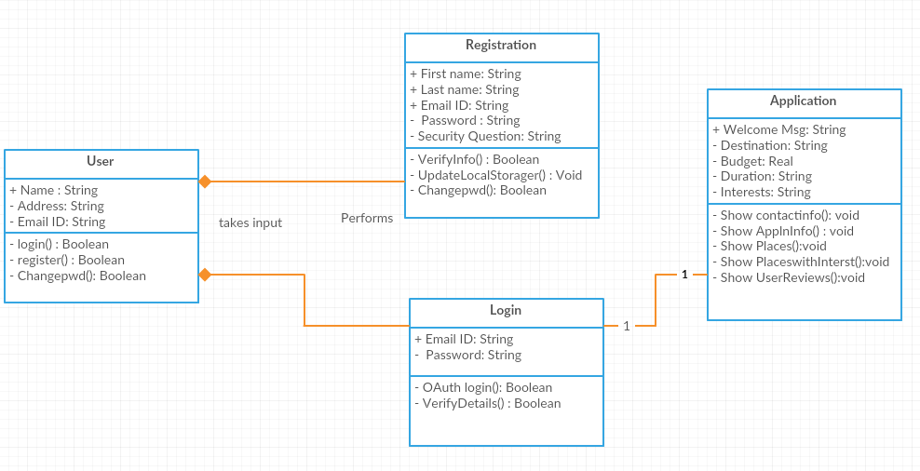

**3. User Stories**

|  |  |  |
| --- | --- | --- |
| **As a** | **I want to** | **So that** |
| User | See list of places of a given destination | I can select from the places available |
|  |  |  |
| User | Filter the places based on my interest | I can select my places of interest |
|  |  |  |
| User | See the Ratings and User Reviews of the given place | I can make the best choice |
|  |  |  |
| Developer | Migrate the local storage to MongoDB | I can access my data from cloud |
|  |  |  |
| User | Create UML Diagrams | Structure and flow of code will be understood |
|  |  |  |

**4. Testing**

|  |  |  |  |  |  |
| --- | --- | --- | --- | --- | --- |
| **ID** | **Test Case** | **Test Case Description** | **Input** | **Expected** | **Result** |
| 1.1 | Register | Open Web application and select new user and signup option. | User clicks on signup button. | Register page opens up. | Pass |
| 1.2 | Register | User enters first name with only alphabets. | User fills out first name field. | Application should accept it | Pass |
| 1.3 | Register | User fills out first name fields with numbers or Special characters. | User fills out first name field. | Application should show error message. | Pass |
| 1.4 | Register | User enters last name with only alphabets. | User fills out last name field. | Application should accept it | Pass |
| 1.5 | Register | User fills out last name fields with numbers or Special characters. | User fills out last name field. | Application should show error message. | Pass |
| 1.6 | Register | User fills out email which is preceded with @ and .com | User fills out email fields. | Application should accept it | Pass |
| 1.7 | Register | User fills out email which is not preceded with @ and .com | User fills out email fields. | Application should show error message. | Pass |
| 1.8 | Register | User entering same email ID again | User Name Already Available | User Name Already Available | Pass |
| 1.9 | Register | Password and confirm password matches. | User fills out password and confirm password field. | Application should accept it | Pass |
| 1.10 | Register | Password and confirm password don’t match. | User fills out password and confirm password field. | Application should show error message. | Pass |
| 1.11 | Register | User leaves Mandatory field empty. | User fills out input fields. | Application should show error message | Pass |
| 1.12 | Register | User fills out all Mandatory fields. | User fills out input fields. | Application should accept it | Pass |
| 1.13 | Register | After entering input fields User clicks Register button. | User click Register button. | All input entered by user should be taken and stored and is redirected to login page. | Pass |
| 2.1 | Login | With Valid Username and Password. | User enters Valid Username and Password. And press login button | Should redirect Home page | Pass |
| 2.2 | Login | With Invalid Username and valid Password. | User enters invalid Username and valid Password and press login button | Should Show incorrect Username error message | Pass |
| 2.3 | Login | With Valid Username and invalid Password. | User enters Valid Username and invalid Password and press login button | Should Show incorrect password error message | Pass |
| 2.4 | Login | With invalid Username and invalid Password. | User enters invalid Username and invalid Password and press login button | Show incorrect credentials error message | Pass |
| 2.5 | Login | User without registration can also login using Google. | User enters correct Google credentials. | Redirects to homepage. | Pass |
| 2.6 | Login | User without registration can also login using Google. | User enters incorrect Google credentials. | Google shows error message. | Pass |
| 2.7 | Login | User without registration can also login using Facebook. | User enters correct Facebook credentials. | Redirects to homepage. | Pass |
| 2.8 | Login | User without registration can also login using Facebook. | User enters incorrect Facebook credentials. | Facebook shows error message. | Pass |
| 3.1 | Home | Values in the destination field is character | User enters character | No error | Pass |
| 3.2 | Home | Values in the destination field is number | User enters number | Numbers are not allowed in the destination | pass |
| 3.3 | Home | Destination is entered and interest is not selected | Destination: Kansas  Interest: Select | All the places for that destination are displayed | pass |
| 3.4 | Home | Destination is entered and interest is Museum | Destination: Kansas  Interest: Museum | All the Museums for that destination are displayed | pass |
| 3.5 | Home | Destination is entered and interest is Adventure | Destination: Kansas  Interest: Adventure | All the Adventure places for that destination are displayed | pass |
| 3.6 | Home | Destination is entered and interest is Devotional | Destination: Kansas  Interest: Devotional | All the Devotional places for that destination are displayed | pass |
| 3.7 | Home | Destination is entered and interest is Scenic | Destination: Kansas  Interest: Scenic | All the Scenic places for that destination are displayed | pass |
| 3.8 | Home | Destination is entered and interest is Party | Destination: Kansas  Interest: Party | All the Party places for that destination are displayed | pass |
| 4.1 | About | User Successfully logins and press About tab. | User press About button. | About Page should open that contains website details. | Pass |
| 5.1 | Contact | User Successfully logins and press Contact tab. | User press Contact button. | About Page should open that contains contact details. | Pass |
| 6.1 | Logout | User will be logged out from website. | User clicks logout button. | Should be logged out of application and redirected to login page. | Pass |

**Travel Explorer – Web Application:**

**Login Page**

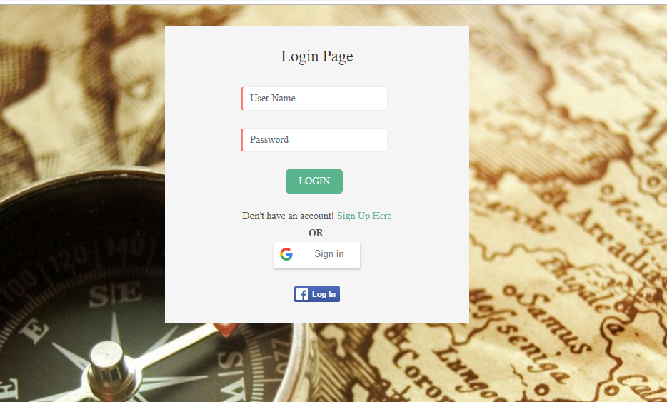

This is the first page that a user will be seeing upon reaching to website. Registration of a user is must before logging into the system. User can login with his credentials entered during Registration or can login using Google or Facebook authentication.

User will be successfully logged into the system if Credentials are right, if Username and Password does not match, user will be prompted that the credentials are wrong.

**Registration Page**

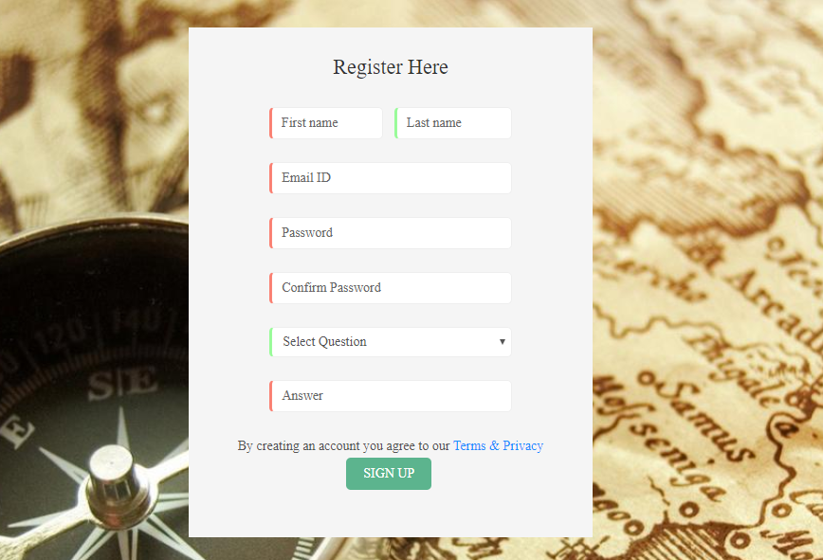

Upon clicking Sign Up Here link in the Login Page user will be prompted to Registration page,

here user should enter the details like First Name, Last Name, Password, Confirm Password,

Choose a Security Question, Answer for it and has to agree to Terms and conditions. Upon pressing Signup button user will be successfully registered.

User will now be prompted to Login Page, Some fields in the Registration Page are mandatory.

**Home Page**



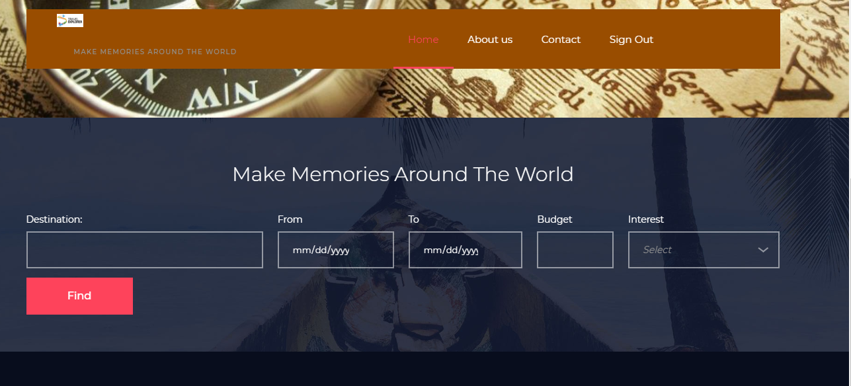

Home page consists of a Tab which links to Contact, About Us pages and to Logout from the System. It takes the User Input of Destination, from and to dates of the trip, Budget of the User and Interests.

**About Us**

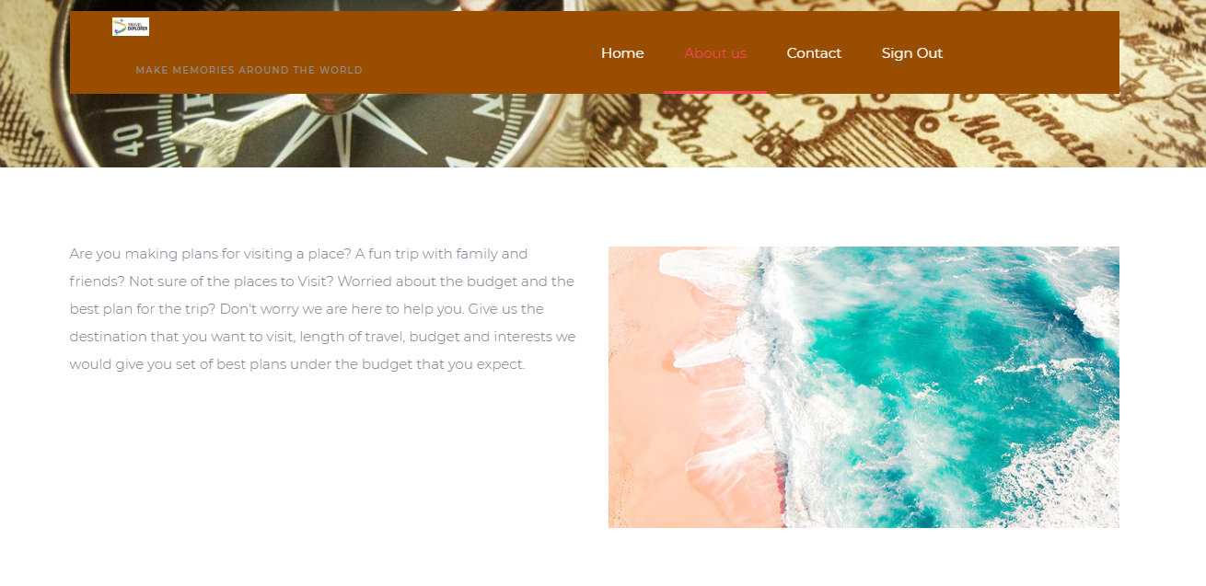

This page tells about why a user should be using our website.

**Contact Page**

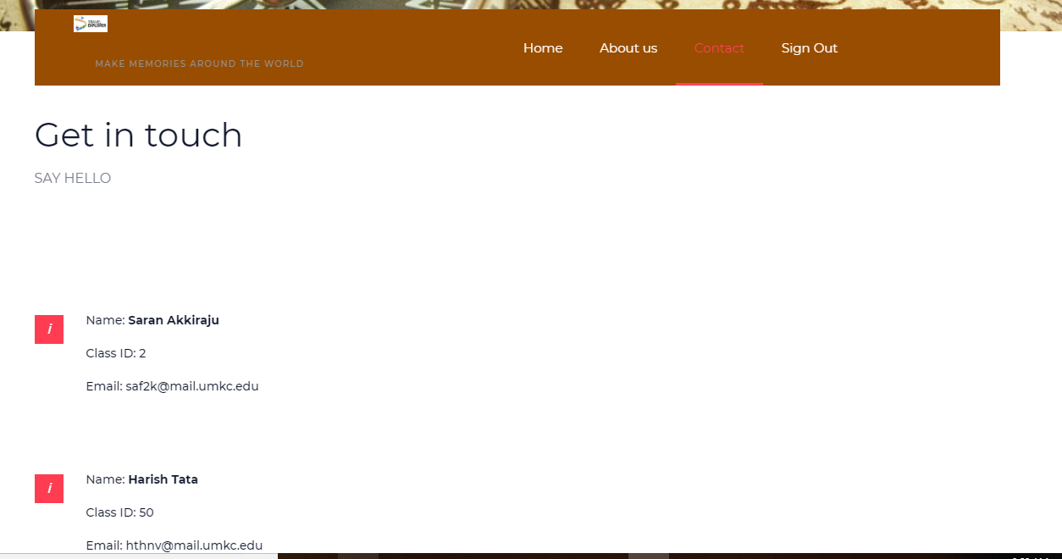

**Please find Github Wiki below:**

**Project Management**

**Board Issues:**

**ZenHub report:**

**Contribution chart:**

**References:**